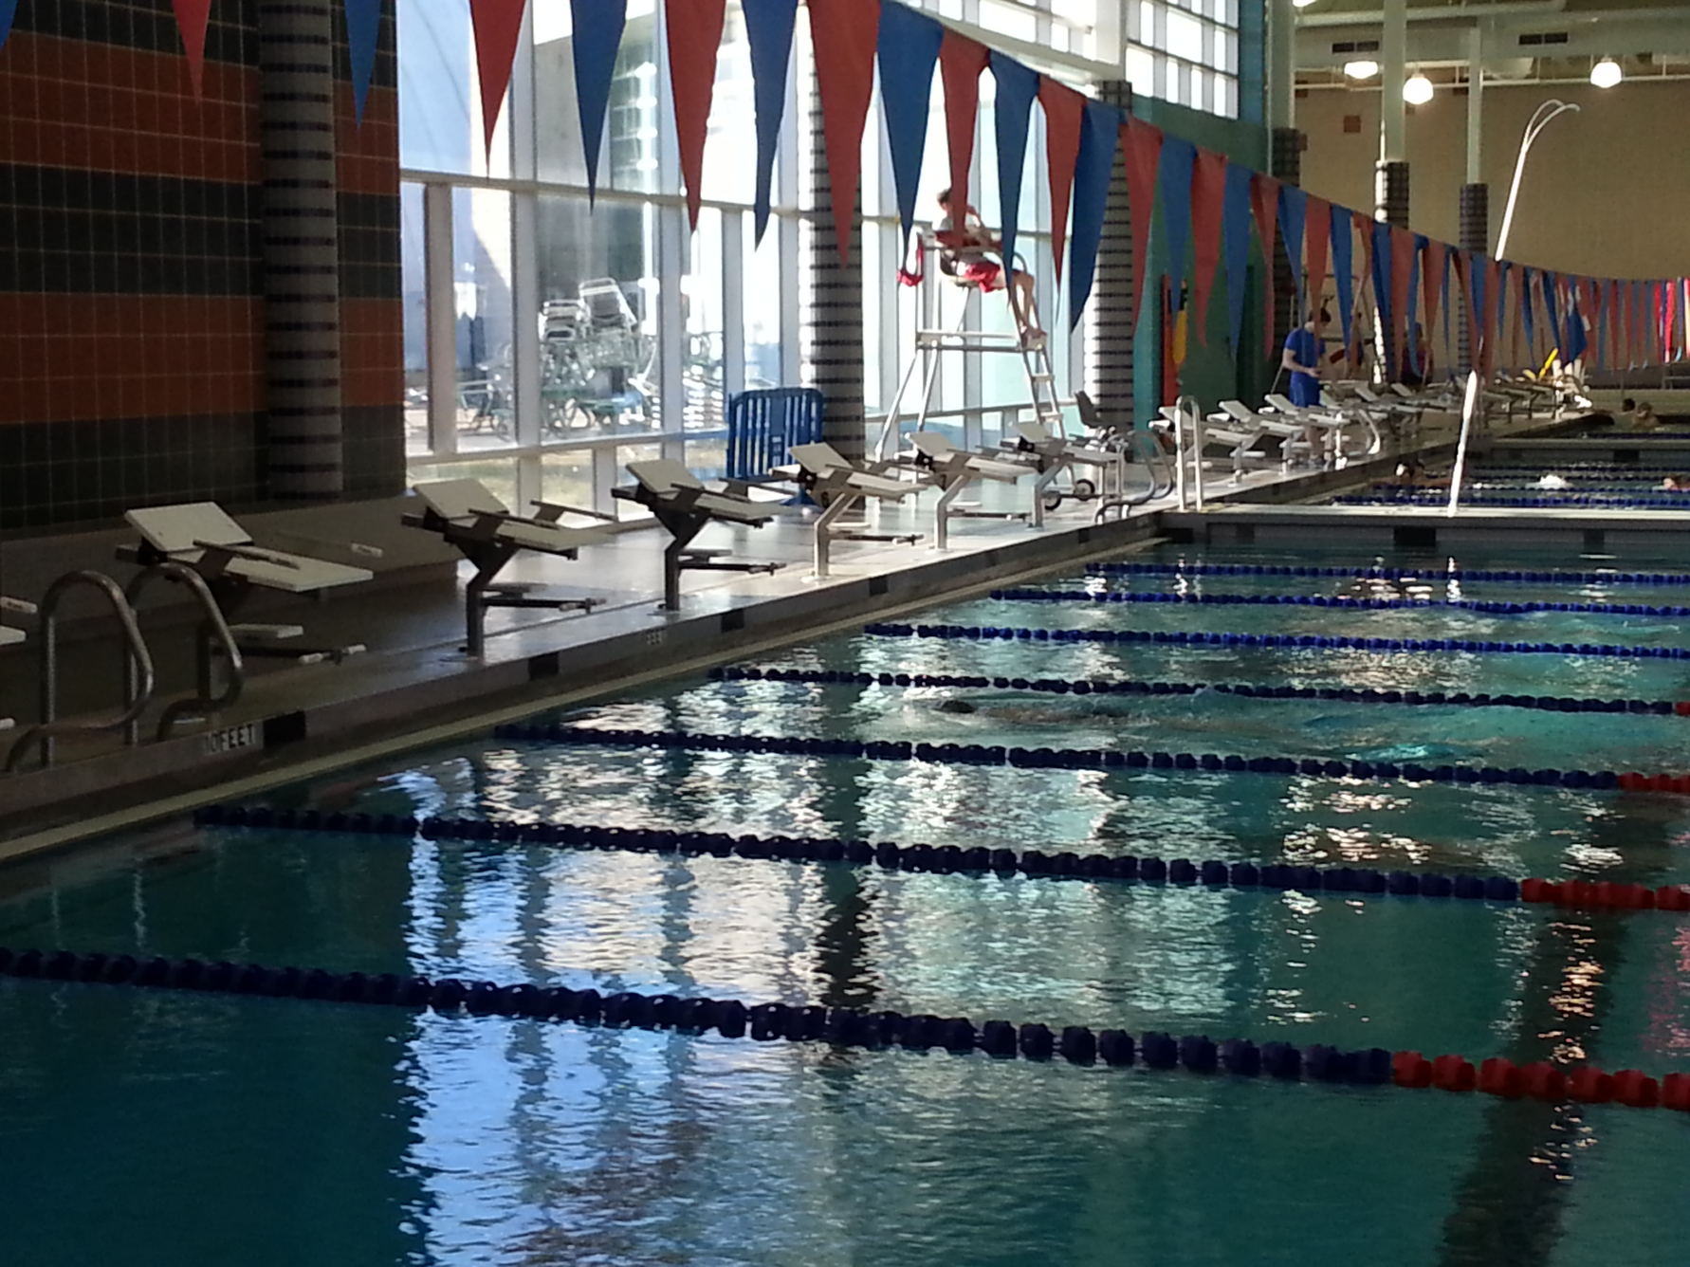
2016 FAST Banquet

When? Wednesday, June 29
Where? Holiday Inn, College Park
Time? 5:30 – 8:30 pm

Menu To follow when finalized

Cost? $ 20 parents / adults Checks payable to FAST
$ 5 swimmers

Please RSVP by June 21

Name: _________________________

# of Adults ____
# of Swimmers ____

